Quick Links (not all sections have a link)
Prospects Action Menu
Prospects Result Table
Prospects Result Table: More Menu
New Email Window
New Email: Email lookup Window

General Formatting
Colors:
Blue:
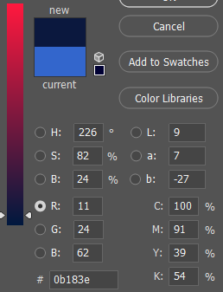
Gold:
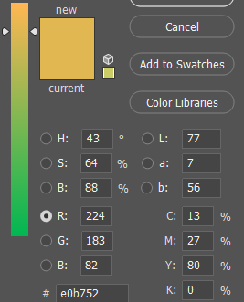

Table Lines
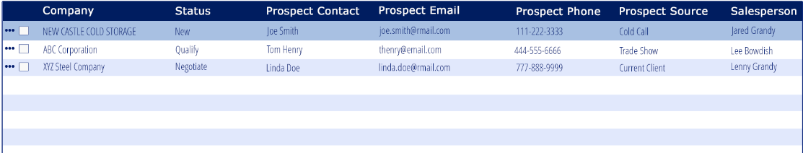
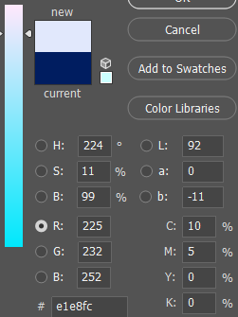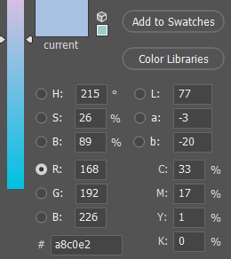

Fonts:

General text, field labels: Open Sans
-fallback: open sans, helvetica neue, helvetica, arial, sans-serif

Headers, title bars, buttons: Verdana
-fallback: Verdana, Geneva, sans-serif

Formatting
Text
text should automatically be converted to all-caps after the user is done typing

Phone/Fax
-all phone & fax fields should auto format the number to be in the formatting shown:
*United States & Canada - (xxx) xxx-xxxx
*Mexico, acceptable formats
- (xx) xx xxxx xxxx
- (xx xx) xxxx xxxx
- (xx) xxxx xxxx
- xx xxxx xxxx for cellphones from Greater Mexico City, Guadalajara and Monterrey
- xxx xxx xxxx for those based elsewhere.
*China
- (xxx) xxxx xxxx
*https://en.wikipedia.org/wiki/National_conventions_for_writing_telephone_numbers#China

Date
-date fields
-format: mm/dd/yyyy
– when manually entered by user rather than selected from the calendar option the format should convert the format
EX: 02/01/17 - 02/01/2017

Postal Code
-the system should recognize the postal code with or without spaces or dashes
-Ex: A0A1A0 can also be put in as A0A 1A0 – both should be recognized by the system
-see the link provided for various postal code formatting and needed character spacing
https://en.wikipedia.org/wiki/List_of_postal_codes
Time
-time format h:mm a
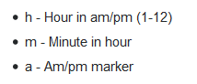
hour is numbers only
minutes is numbers only
AM/PM is selection based
If the user types A AM is selected if the user types P PM is selected
AM/PM should be display in all-caps

-user should be able to type the time in or click the clock icon to select a time

-before a time is entered there should be dashes where the data will be entered

-when the clock icon is clicked the time options should look like the image below
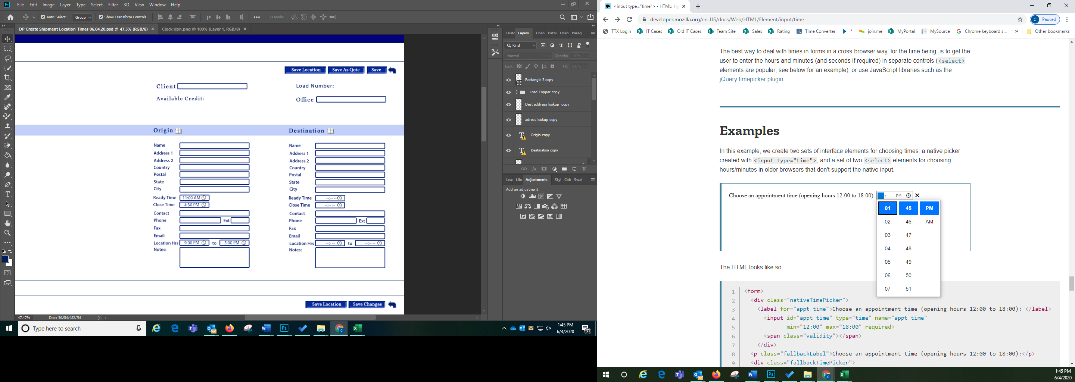

Calendars
– anywhere a calendar appears
-1st open the icon
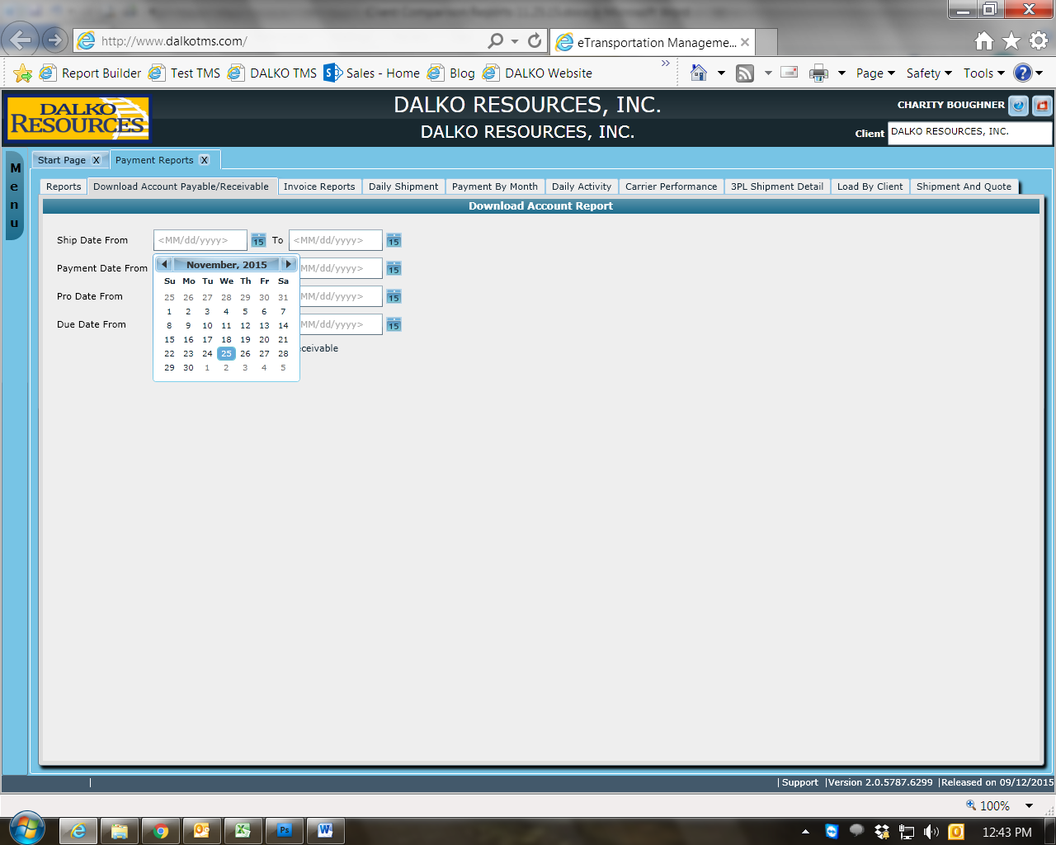
-when you click on the month it should convert the calendar to this view
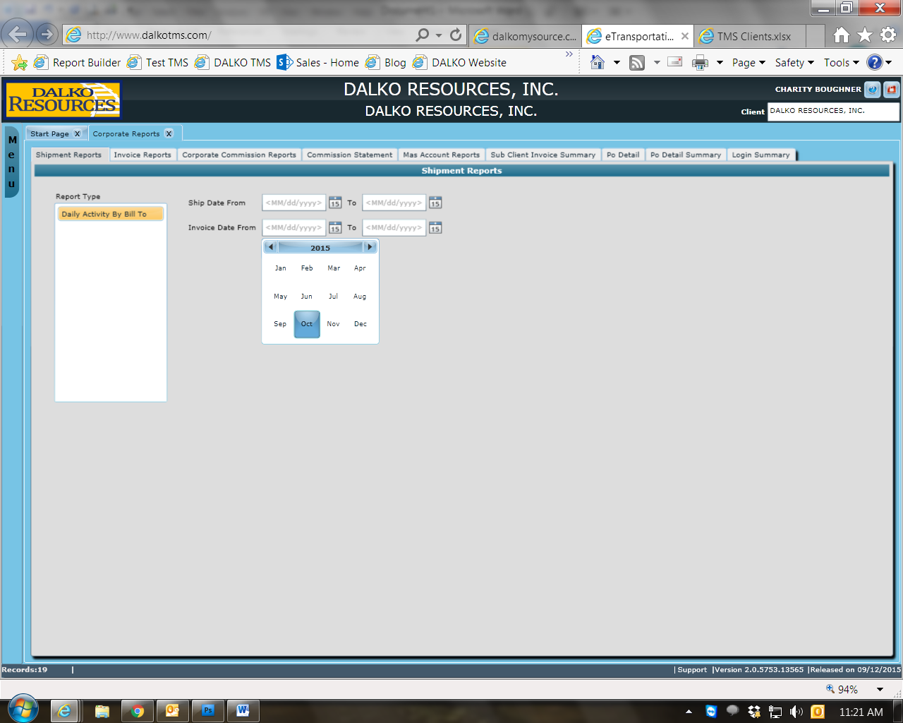

-when you click in the year is should convert this view
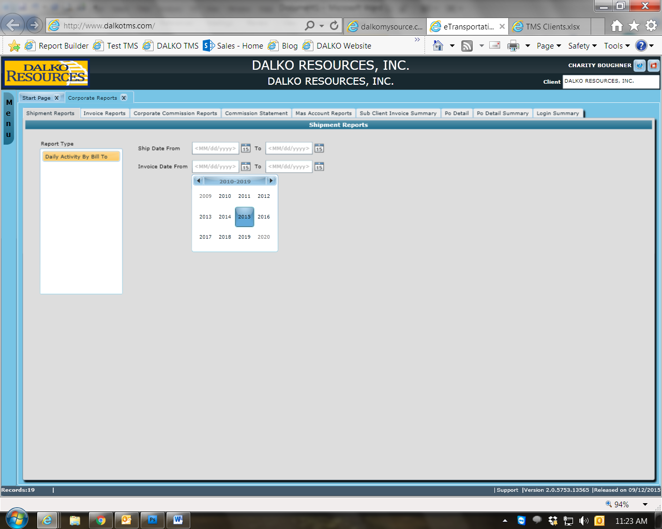
**the calendar views should work in reverse as the user select the information

Page Navigation
-Items Per Page – dropdown
- determines the number of vendors showed per page
-options: 10, 25, 50, 100
-Page Number
-displays the page number the user is currently on and how many pages there are in total
-if the user enters a page number it should jump to that page
-single arrow move forward or back one page
-arrow with line jumps to first or last page

Buttons/Fields
-Radial & checkbox buttons – use keystroke Space to select

-All other buttons – use keystroke Enter to select

-Dropdown –
- fields with dropdown lists should be blank by default unless otherwise stated in this document or setup with a default item through the system
-ex: fields such as Payment Terms & Product Class can be defaulted through Client Settings

- there should always be a blank option in the dropdown field unless it is a required field or stated otherwise for a particular field

- should always be in alphabetical or numerical order unless otherwise states
-shortcut within the dropdown list based on the first character
-ex: when E is typed the selection box should jump down to the first word in the list that starts with E

Required Fields
-the field should be flagged with a red vertical bar to indicate it is required

-if the user bypasses a required field without completing it the input box should turn red and there should be a message below the input field in red font
-Alert dependent on the missing required field

Message Examples:
Name is required
Effective Date is required
Expiration Date is required

General Validation
*all open input field should be spellchecked
*all open input field should auto capitalize except where noted

CRM Terminology
Lead – a company with the Status of New Lead, Contact or Qualify
Prospect – a company with the Status Present, Proposal, Pursuit, Negotiate, or On Board
Client – a company with the Status Client
-can be a Lead or Prospect that has been converted to a Client or a company could be created as a Client skipping the Lead/Prospect process

Prospects
Purpose:
-To add the screen where Prospects can be created, viewed and/or updated

Appearance:
Default View
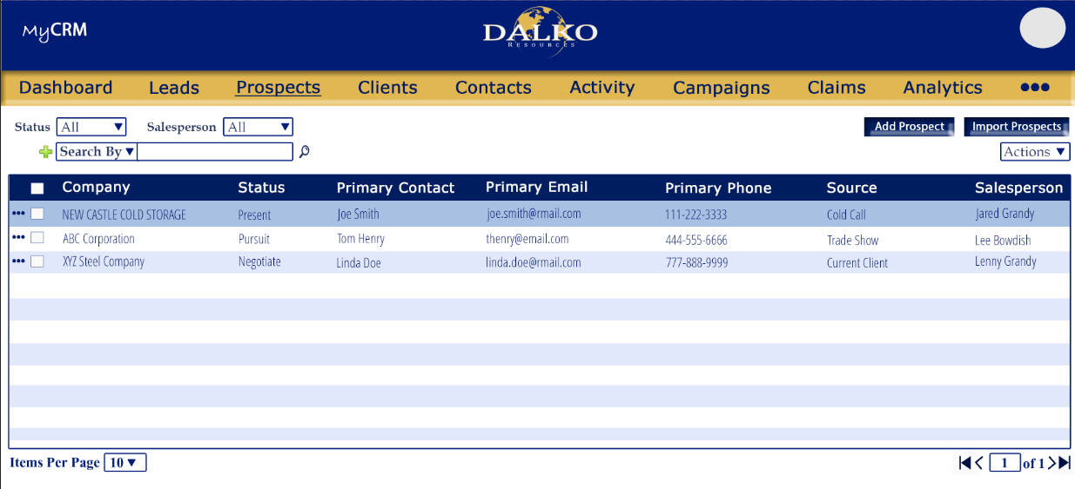

Prospect Expanded
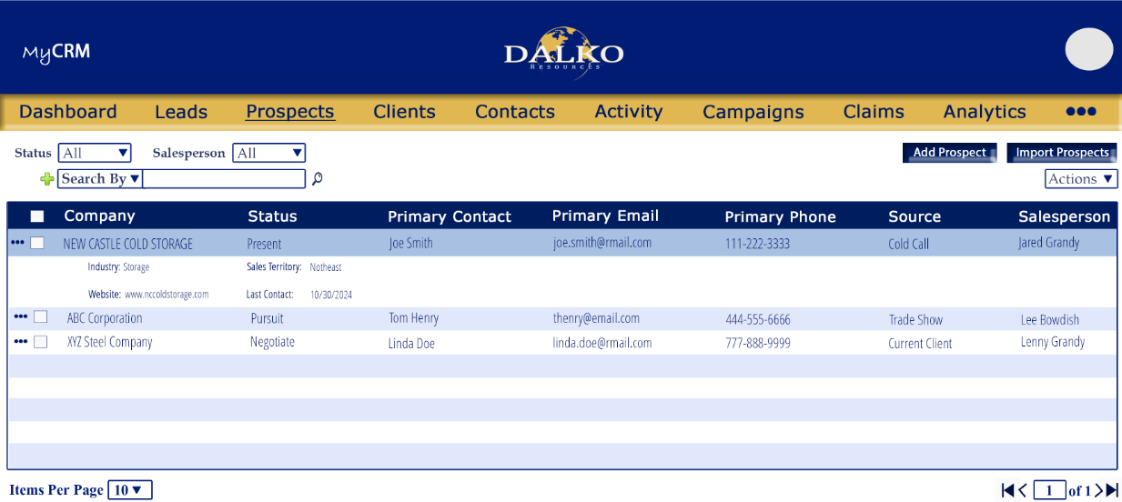

*appearance and layout per the images provided

Tab Order:
- Status
- Salesperson
- Search by menu
- Search Buy input field
- Find icon
- Add Search by option
- Remove search option icon
- Repeat steps 2 through 6 until the user is done adding search by options

Required fields
- No requirements for overall screen

Fields
Status
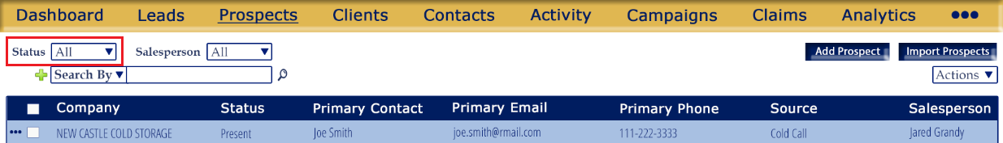

Function:
-Used to filter the existing Prospects based on their status

Details
-multi select, dropdown menu
-default to All
-Looks at Add Prospects>Company Information>Status field
-options:
  - Present
  - Proposal
  - Pursuit
  - Negotiate
  - On Board

Validation:
-
Salesperson
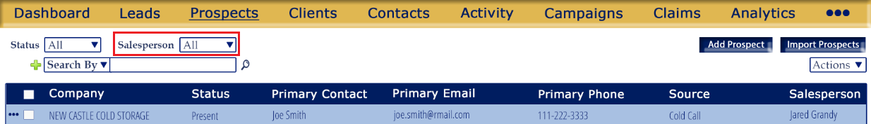

Function:
-Used to filter the existing Prospects based the Salesperson(s) assigned to them

Details
-multi select, dropdown menu with search
Ex:
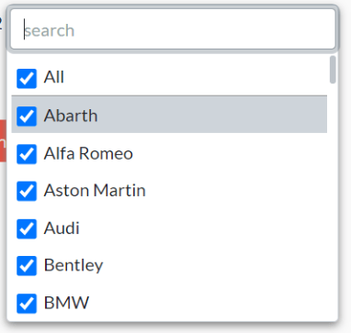
-default to All
-Looks at Add Prospects>Company Information>Salesperson field
-options come from users master, users that are role “Salesperson”
-full name should show

Validation:
-

Search
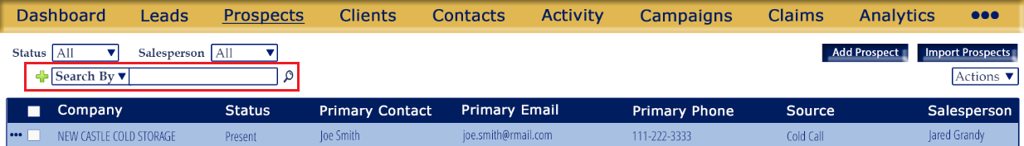
Function:
-Used to search the existing Prospects based on the selection made.

Details
-Search by options are displayed in a dropdown menu. Once the user selects a Search by option the search input field will populate based on the users selection
*Input fields vary based on the Search By chosen
-the user has the ability to add as many Search By set as there are search by options available
-every search by field should have a remove option
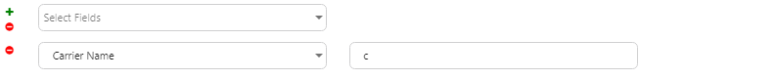
-sort Search By options alphabetically
-search by option details:
  - Company Name
  - Prospect Source
  - Client Type
  - Parent Account
  - Industry
  - Sales Territory
  - Office
  - Country
  - State
  - City
  - Postal
  - Contact Name
  - Contact Email
  - Contact Phone No
  - Contact Owner
  - Created Date

-search by option details:
  - Company Name
    - Looks at Add Prospect>Company Information>Company name field
    - Open format input field
  - Prospect Source
    - Looks at Add Prospect>Company Information>Company name field
    - Dropdown menu with checkboxes
    - User can select one or multiple options at once
    - List options alphabetically
    - Options:
      - Advertisement
      - Cold Call
      - Employee Referral
      - Client Referral
      - Supplier Referral
      - External Referral
      - Trade Show
      - Web Research
      - Email Marketing
      - Website Visitor
      - Purchased List
      - Other
  - Client Type
    - Looks at Add Prospect>Company Information>Client Type field
    - Dropdown menu with first letter shortcut
    - User can only select one
    - List options alphabetically
    - Options:
      - Standard
      - Parent
      - Subsidiary
  - Parent Account
    - Looks at Add Prospect>Company Information>Parent Account
    - Dropdown menu with smart search
      - The more the user enters the more the options are narrowed down
    - Options come from Leads, Prospects and Clients that are Client Type Parent
    - Results will show Prospects that have the selected parent type selected in their Parent Account field
  - Industry
    - Looks at Add Prospect>Company Information>Industry
    - multi select, dropdown menu with search
Ex:

    - options should be listed alphabetically
    - options:
      - Passenger Rail
      - Logistics Company
      - Track/MOW
      - Rail
      - Rail – Shortline
      - Rail – Repair
      - Rail – Parts
      - Rail – New Car
      - Power Generation
      - Automotive
      - Non-Rail Misc
      - Mining
      - Govt/Military
      - Distributor
      - Chemicals
      - Cement
      - Retail
      - Agriculture
      - Healthcare
      - Clothing/Apparel
      - Computer/Electronic
      - Fabricated Metal Products
      - Food Manufacturing
      - Forestry/Logging
      - Furniture
      - Machinery
      - Manufacturing
      - Oil/Gas
      - Petroleum/Coal Product Manufacturing
      - Pipeline
      - Plastic/Rubber Products Manufacturing
      - Metal Manufacturing
      - Paper Manufacturing
      - Household Goods
      - Wood Product Manufact
      - Lumber/Building Supplies
      - Pet Supplies

  - Sales Territory
    - Looks at Add Prospect>Company Information>Sales Territory field
    - multi select, dropdown menu with search
Ex:

    - options should be sorted alphabetically
    - options:
      - International
      - Northeast
      - Northwest
      - Southwest
      - Southeast
  - Office
    - Looks at Add Prospect>Company Information>Office
    - Open input
    - Like search
  - Country
    - Looks at Add Prospect>Company Information>Mailing Adress Country and Physical Address Country fields
    - Open input
    - Like search
  - State
    - Looks at Add Prospect>Company Information>Mailing Adress State and Physical Address State fields
    - Open input
    - Like search
  - City
    - Looks at Add Prospect>Company Information>Mailing Adress City and Physical Address City fields
    - Open input
    - Like search
  - Postal
    - Looks at Add Prospect>Company Information>Mailing Adress Postal and Physical Address Postal fields
    - Open input field
    - Like search
  - Contact Name
    - Looks at Add Prospect>Contacts list name column
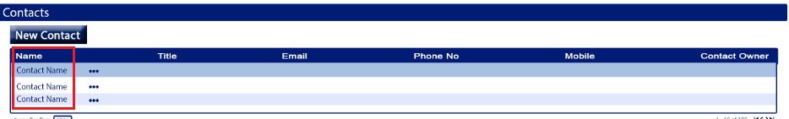
    - Open input field
    - Like search
  - Contact Email
    - Looks at Add Prospect>Contacts list email column
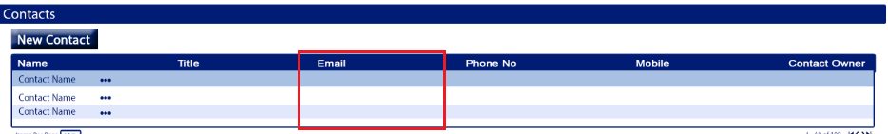
    - Open input field
    - Like search
  - Contact Phone No
    - Looks at Add Prospect>Contacts list Phone No and Mobile column
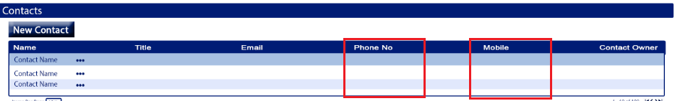
    - Open input field
    - Like search
  - Contact Owner
    - Looks at Add Prospect>Contacts list Contact Owner column
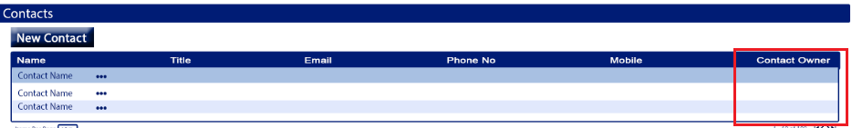
    - Open input field
    - Like search
  - Created Date
    - Looks at the date the Prospect was created
    - Date range field
    - User can hand enter the date or select from calendar
    - Search tab order needs adjusted to include the from and two input fields
      - The calendar should not be included in the tab order
    - format: mm/dd/yyyy
    - when manually entered by user rather than selected from the calendar option the format should convert the format
EX: 02/01/17 - 02/01/2017

Validation:
-if a search by options is selected and the user clicks the search button but the input field is null there should be an alert “Please enter search criteria”
-user can add multiple search by option without input data without the system stopping them or alerting them. The alert should only open is one or more of the search input fields are null when they click the search button

Add Prospect
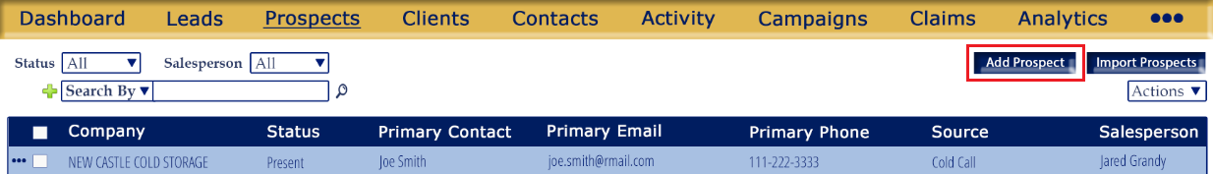

Function:
-Allows the user to add a new Prospect
Details
-button
-refer to image for placement and appearance
-opens the Add Prospect screen
-hover text: “Add new Prospect”
Validation:
-

Import Prospects
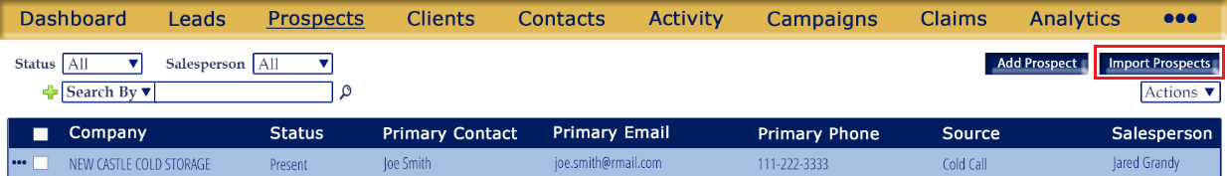

Function:
-Allows the user to upload new Prospects from cvs, Excel (xls, xlsx)
-same functionality as the Import Data button on the current Leads screen
Details
-button
-refer to image for placement and appearance
-keep the existing functionality and rules
-hover text: “Upload Prospects from Excel or CSV”
Validation:
-same as current function

Actions menu
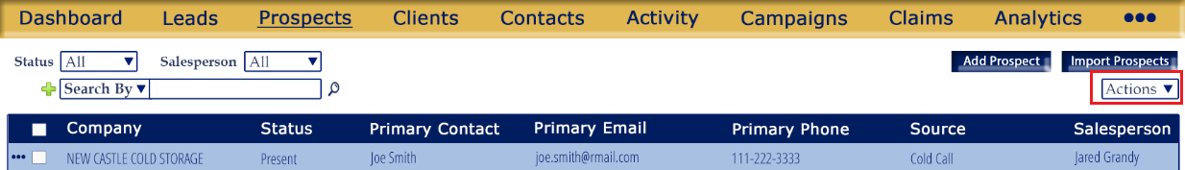

Function:
-menu for actions that would be applied to 1 or more selected Prospects

Details
-dropdown menu
-refer to image for placement and appearance
-options should be sorted alphabetically
-options:
- Export
- Mass Delete
- Mass Convert
- Mass Email
Validation:
-at least one Prospect must be selected
Aler message: “Please select Prospect(s) to continue”

Actions menu: Export


Function:
-used to export selected Prospects
Details
-option in the Actions menu that triggers an export
-as soon as the options “Export” is selected the Prospects the user selected will be exports to an Excel file
-fields included in the exported file in the order given:
- Company Name
- Status
- Sales Territory
- Salesperson
- Office
- Prospect Source
- Client Type
- Parent Account
- Last Contacted
- Industry
- Annual Revenue
- Website
- Linked Inn
- Mailing Address: Country
- Mailing Address: Address 1
- Mailing Address: Address 2
- Mailing Address: City
- Mailing Address: State
- Mailing Address: Postal
- Physical Address: Country
- Physical Address: Address 1
- Physical Address: Address 2
- Physical Address: City
- Physical Address: State
- Physical Address: Postal
- Column for each Contact Name
- Column for each Contact Title
- Column for each Contact Email
- Column for each Contact Phone No
- Column for each Contact Mobile
- Column for each Contact Contact Owner
Validation:
-at least one Prospect must be selected
Alert message: “Please select Prospect(s) to continue”

Actions menu: Mass Convert


Function:
-used to convert all selected Prospects to a Client
Details
-option in the Actions menu that triggers selected Prospects to be converted to Client
-as soon as the options “Mass Convert” is selected there will a popup
Message: “The selected Prospects will be converted to a Clients. Do you wish to continue?
Proceed: Will close the alert and convert the selected Prospects to Clients
Cancel: Will close the alert, return the user to the Prospects screen and no Prospects will be updated

Validation:
-at least one Prospect must be selected
Alert message: “Please select Prospect(s) to continue”

Actions menu: Mass Delete


Function:
-used to delete all selected Prospects
Details
-option in the Actions menu that triggers selected Prospects to be deleted
-as soon as the options “Mass Delete” is selected there will a popup
Message: “The selected Prospects will be permanently deleted. Do you wish to continue?
Proceed: Will close the alert and delete the selected Prospects
Cancel: Will close the alert, return the user to the Prospects screen and no Prospects will be deleted

Validation:
-at least one Prospect must be selected
Alert message: “Please select Prospect(s) to continue”

Actions menu: Mass Email


Function:
-used to email all selected Prospects
Details
-option in the Actions menu that triggers a new email window to open
-section detailing the new email popup further down in document
-the contacts from the selected Prospects will populate into the Bcc field of the New Email window

Validation:
-at least one Prospect must be selected
Alert message: “Please select Prospect(s) to continue”

-if the Prospect has any Subsidiary Companies associated with it the user should not be able to delete the Prospect
Message: “This Prospect currently has Subsidiary Companies linked to it and cannot be deleted. The Parent Company of the subsidiaries must first be updated.”
Ok button: will close the alert, and return the user to the Prospects screen without deleting the selected Prospect

-there should be a validation on whether the user wishes to proceed
*this validation should occur only if Prospect/Subsidiary company alert is not triggered

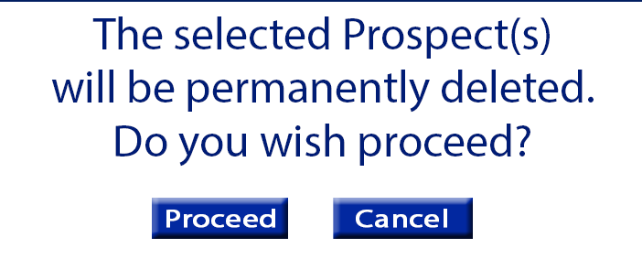

Message: “The selected Prospect(s) will be permanently deleted. Do you wish to continue?”
Proceed: will close the alert and delete the Prospects
Cancel: will close the alert, and return the user to the Prospects screen without deleting the selected Prospect

New Email Window
Appearance
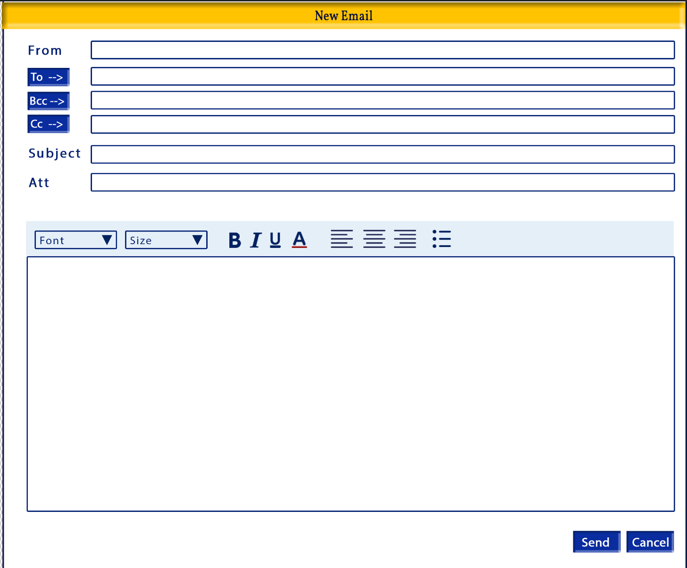

Tab Order:
- From input field
- To button
- To Input field
- Bcc button
- Bcc Input field
- CC button
- Cc Input field
- Subject
- Email Body
- Send
- Cancel

Required
- From input field is required is Send is clicked
- At least one of the following is required is Send is clicked
  - To value
  - Bcc value
  - Cc value

From button
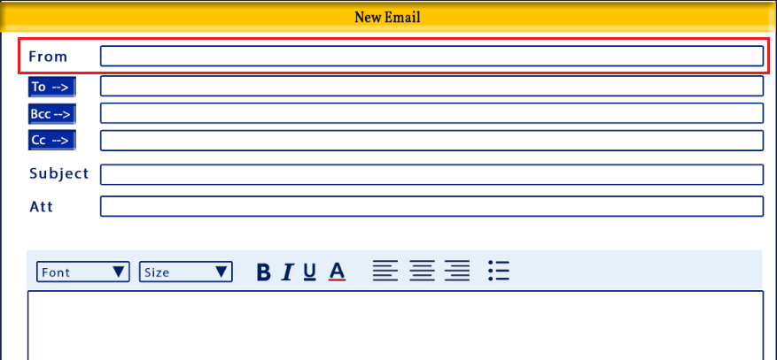

Function:
-displayed as the email address the email is being sent from

Details:
-input field
-format: email
-default to the user’s email address

Validation:
-required is Send is clicked
-must be in proper email formatting

To button
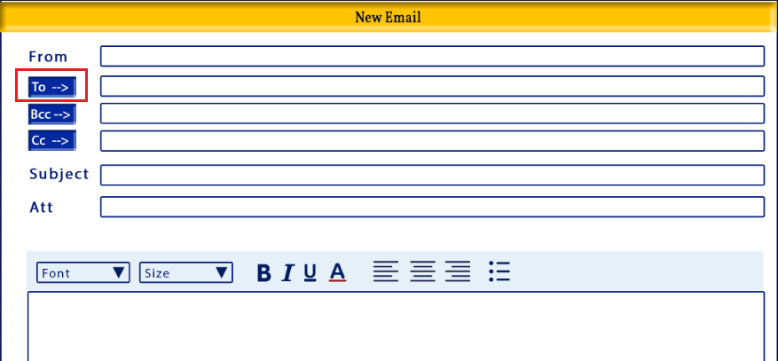
Function:
-opens the Email Lookup window where a user can find an email address to be added to the To input field of the New Email window

Details:
-button
-the Email Lookup window will be detailed in the document below
-hover text: Email Lookup
Validation:
-

To input field
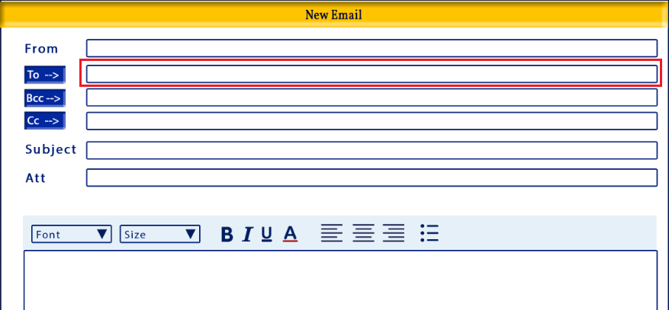
Function:
-input field where the user enters email addresses where the email will be sent to

Details:
-input field
-manually entered by the user or completed by the To button option
-if the To button option was used the user can still add or modify the To input field
-user can enter more than one email address with a semi colon separator

Validation:
-

Bcc button
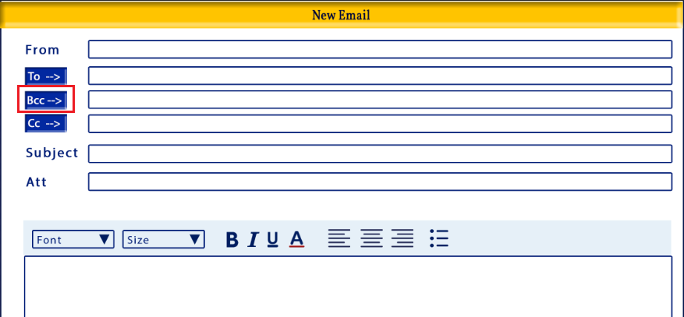
Function:
-opens the Email Lookup window where a user can find an email address to be added to the Bcc input field to the New Email window

Details:
-button
-the Email Lookup window will be detailed in the document below
-hover text: Email Lookup
Validation:
-

Bcc input field
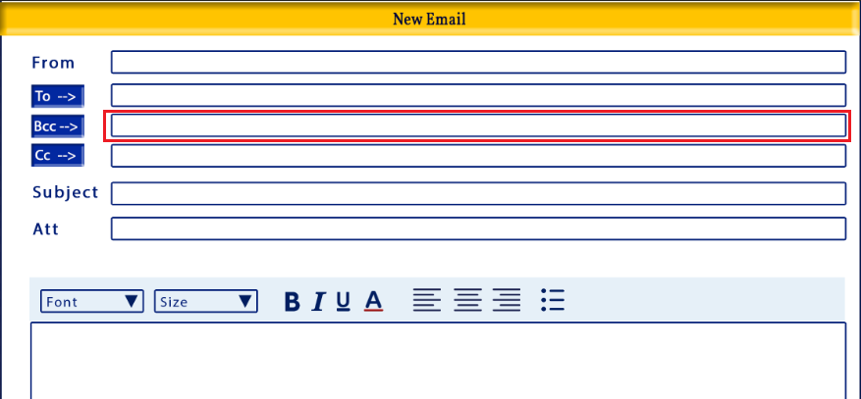
Function:
-input field for email address that should be blind copied in the email being sent

Details:
-input field
-by default all the contact emails for the selected Prospects should be added to this field
-user can manually remove emails that auto-populated
-user can add additional email addresses manually or by using the email lookup option (Bcc button)
-user can enter more than one email address with a semi colon separator

Validation:
-

Cc button
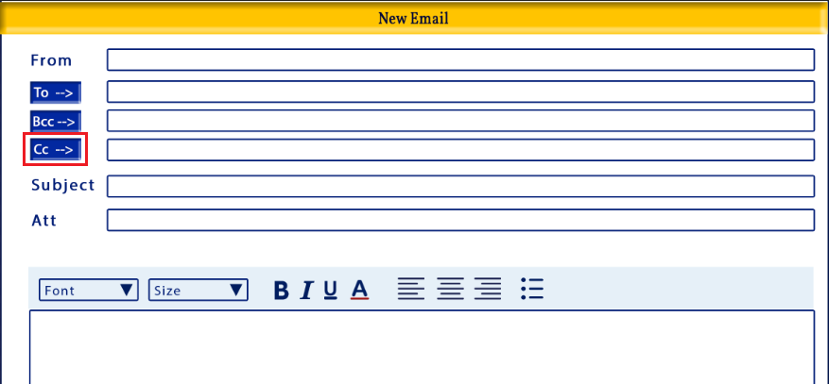
Function:
-opens the Email Lookup window where a user can find an email address(s) to be added to the Cc input field of the New Email window

Details:
-button
-the Email Lookup window will be detailed in the document below
-hover text: Email Lookup
Validation:
-

Cc input field
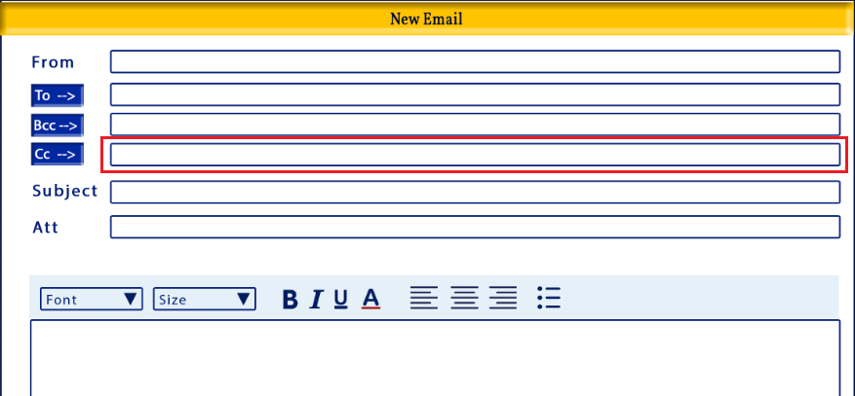
Function:
-input field where the user enters email addresses that will be copied in on the email being sent

Details:
-input field
-manually entered by the user or completed by the Cc button option
-if the Cc button option was used the user can still add or modify the Cc input field
-user can enter more than one email address with a semi colon separator

Validation:
-

Send Email
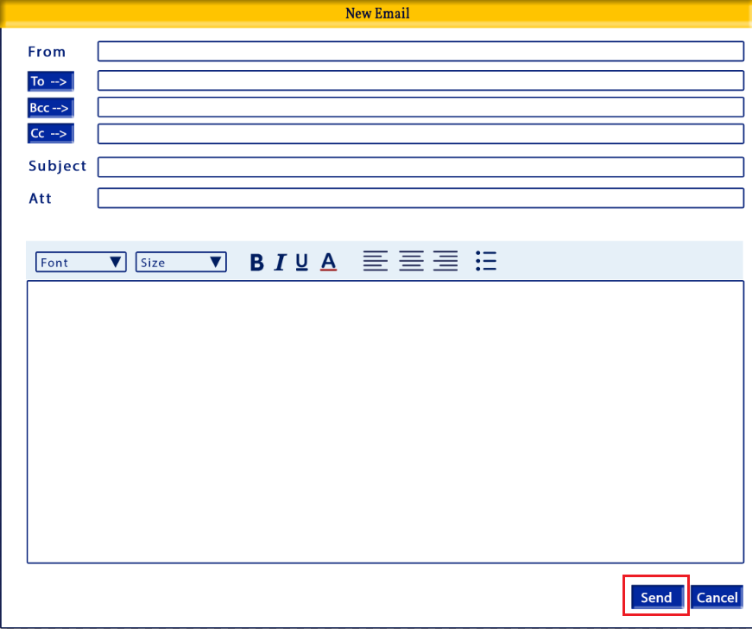
Function:
-used to send the email compose in the New Email window

Details:
-button
-hover text: “Send Email”
Validation:
-From value required
-at least one recipient value you required
-can be from one or all of the following fields: To, Bcc and/or Cc
-Subject required

Cancel
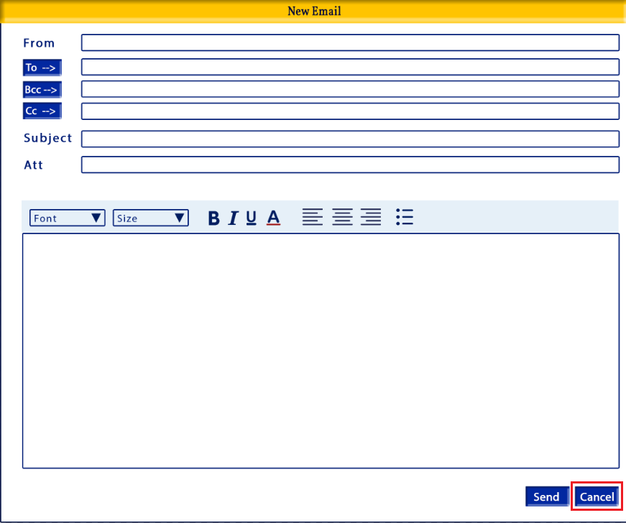
Function:
-closes New Email window without sending an email

Details:
-button
-closes the New Email window and returns the user to the Prospects screen, same view as before they clicked the Mass Email option, no email will be sent

Validation:
-if the user entered any values into the email body, an alert should opens
Message: “Email content will be lost, do you wish to continue?”
Proceed button – closes the New Email window and returns the user to the Prospects screen, same view as before they clicked the Mass Email option, no email will be sent
Cancel button – closes the alert and takes the user back to the New Email window where everything remains as it was before the Cancel button was clicked

Formatting toolbar
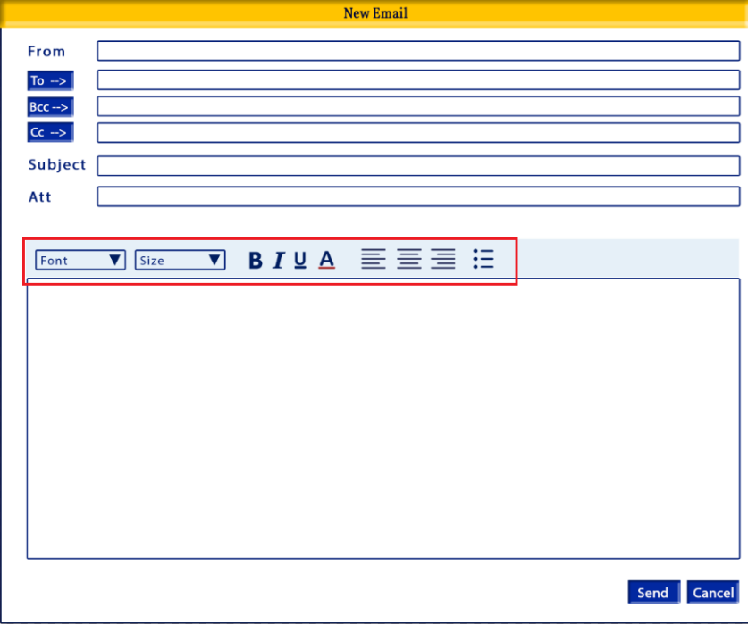
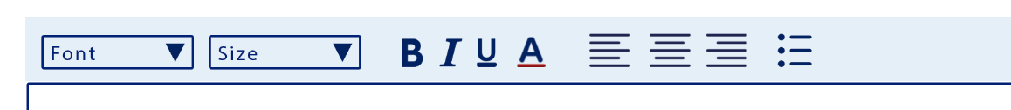
Function:
-used to format the email body text

Details:
-formatting controls include:
- Font
- Font Size
- Bold
- Italics
- Underline
- Font Color
- Alignment: Left, Center & right
- bullets
Validation:
-

New Email Body
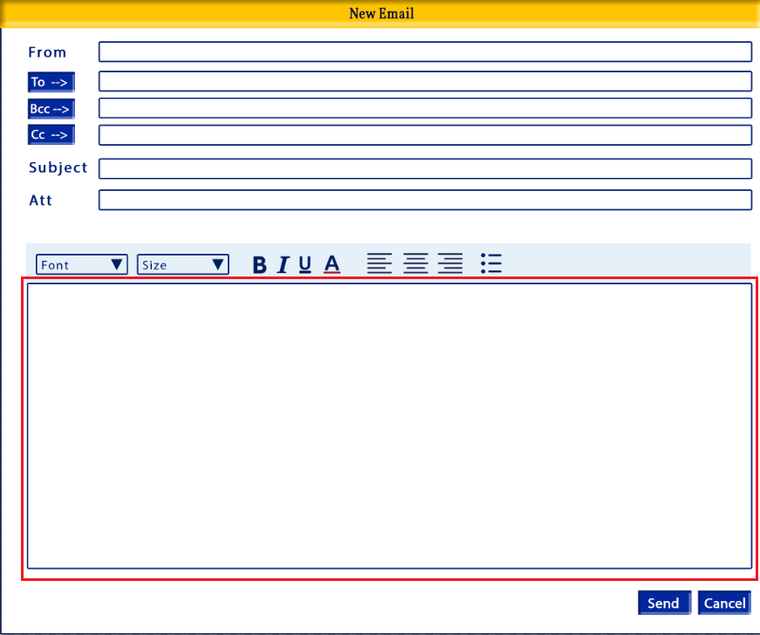
Function:
-used to enter a message into the body of the email

Details:
-open input
-no character limit
-blank by default

Validation:
-at least one value must be entered into the body if the Send button is clicked

New Email Window: Email Lookup
Purpose:
-To allow the user to find an email address for a Prospect, Prospect or Client Contact they wish to email

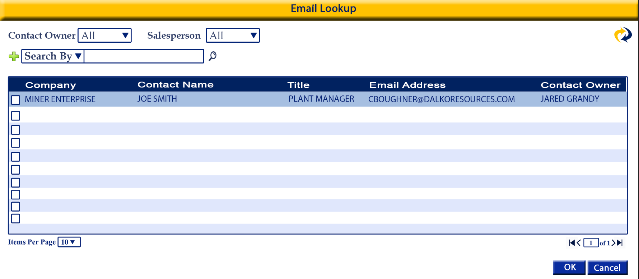

*should like the images provided above
-based on whether the Client Or Vendor is select the filter, Search by and content will change
*order the fields to reflect the image below

Tab Order:

- Client
- Vendor
- Filter by Client/Vendor
- All
- Include Inactive
- Search By
- Search By input
- Find
- Add search option
**repeat 6-9

Required fields

Fields

Contact Owner
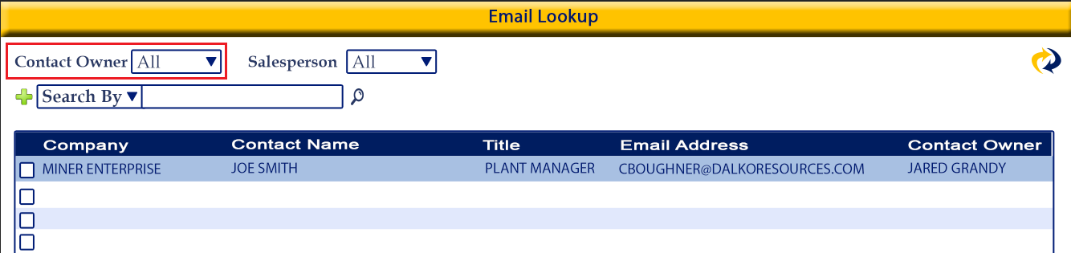

Function:
-Used to filter the existing Prospect Contacts based on the owner of the contact

Details
-multi select, dropdown menu with search
Ex:

-default to All
-Looks at Add Contacts>Contact Information>Contact Owner
-options come from users master
-full name should show

Validation:
-

Salesperson
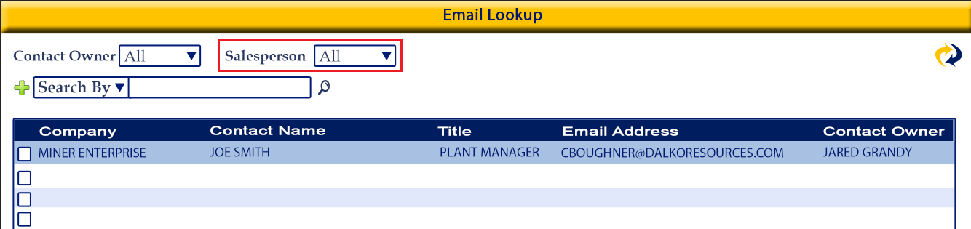

Function:
-Used to filter the existing Prospect Contacts based the Salesperson(s) assigned to the company the contact is saved under

Details
-multi select, dropdown menu with search
Ex:

-default to All
-Looks at Add Prospects>Company Information>Salesperson field
-options come from users master, users that are role “Salesperson”
-full name should show

Validation:
-

Search
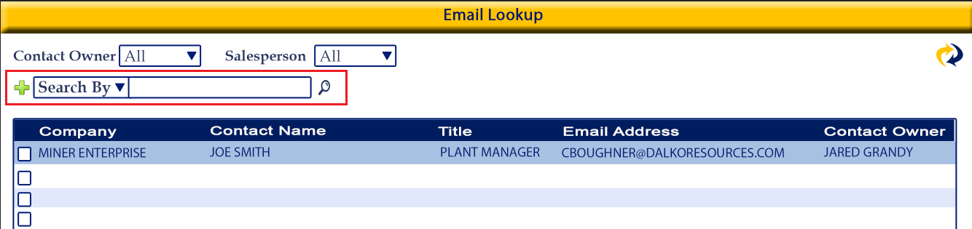
Function:
-Used to search the existing Prospect Contacts based on the selection made.

Details
-Search by options are displayed in a dropdown menu. Once the user selects a Search by option the search input field will populate based on the users selection
*Input fields vary based on the Search By chosen
-the user has the ability to add as many Search By set as there are search by options available
-every search by field should have a remove option

-sort Search By options alphabetically
-search by option details:
  - Company Name
  - Prospect Source
  - Client Type
  - Parent Account
  - Industry
  - Sales Territory
  - Office
  - Country
  - State
  - City
  - Postal
  - Contact Name
  - Contact Email
  - Contact Phone No

-search by option details:
  - Company Name
    - Looks at Add Prospect>Company Information>Company name field
    - Open format input field
  - Prospect Source
    - Looks at Add Prospect>Company Information>Company name field
    - Dropdown menu with checkboxes
    - User can select one or multiple options at once
    - List options alphabetically
    - Options:
      - Advertisement
      - Cold Call
      - Employee Referral
      - Client Referral
      - Supplier Referral
      - External Referral
      - Trade Show
      - Web Research
      - Email Marketing
      - Website Visitor
      - Purchased List
      - Other
  - Client Type
    - Looks at Add Prospect>Company Information>Client Type field
    - Dropdown menu with first letter shortcut
    - User can only select one
    - List options alphabetically
    - Options:
      - Parent
      - Subsidiary
  - Parent Account
    - Looks at Add Prospect>Company Information>Parent Account
    - Dropdown menu with smart search
      - The more the user enters the more the options are narrowed down
    - Options come from Prospect, Prospects and Clients that are Client Type Parent
    - Results will show Prospects that have the selected parent type selected in their Parent Account field
  - Industry
    - Looks at Add Prospect>Company Information>Industry
    - multi select, dropdown menu with search
Ex:

    - options should be listed alphabetically
    - options:
      - Passenger Rail
      - Logistics Company
      - Track/MOW
      - Rail
      - Rail – Shortline
      - Rail – Repair
      - Rail – Parts
      - Rail – New Car
      - Power Generation
      - Automotive
      - Non-Rail Misc
      - Mining
      - Govt/Military
      - Distributor
      - Chemicals
      - Cement
      - Retail
      - Agriculture
      - Healthcare
      - Clothing/Apparel
      - Computer/Electronic
      - Fabricated Metal Products
      - Food Manufacturing
      - Forestry/Logging
      - Furniture
      - Machinery
      - Manufacturing
      - Oil/Gas
      - Petroleum/Coal Product Manufacturing
      - Pipeline
      - Plastic/Rubber Products Manufacturing
      - Metal Manufacturing
      - Paper Manufacturing
      - Household Goods
      - Wood Product Manufact
      - Lumber/Building Supplies
      - Pet Supplies

  - Sales Territory
    - Looks at Add Prospect>Company Information>Sales Territory field
    - multi select, dropdown menu with search
Ex:

    - options should be sorted alphabetically
    - options:
      - International
      - Northeast
      - Northwest
      - Southwest
      - Southeast
  - Office
    - Looks at Add Prospect>Company Information>Office
    - Open input
    - Like search
  - Country
    - Looks at Add Prospect>Company Information>Mailing Adress Country and Physical Address Country fields
    - Open input
    - Like search
  - State
    - Looks at Add Prospect>Company Information>Mailing Adress State and Physical Address State fields
    - Open input
    - Like search
  - City
    - Looks at Add Prospect>Company Information>Mailing Adress City and Physical Address City fields
    - Open input
    - Like search
  - Postal
    - Looks at Add Prospect>Company Information>Mailing Adress Postal and Physical Address Postal fields
    - Open input field
    - Like search
  - Contact Name
    - Looks at Add Prospect>Contacts list name column

    - Open input field
    - Like search
  - Contact Email
    - Looks at Add Prospect>Contacts list email column

    - Open input field
    - Like search
  - Contact Phone No
    - Looks at Add Prospect>Contacts list Phone No and Mobile column

    - Open input field
    - Like search

Validation:
-if a search by options is selected and the user clicks the search button but the input field is null there should be an alert “Please enter search criteria”
-user can add multiple search by option without input data without the system stopping them or alerting them. The alert should only open is one or more of the search input fields are null when they click the search button

Items Per Page
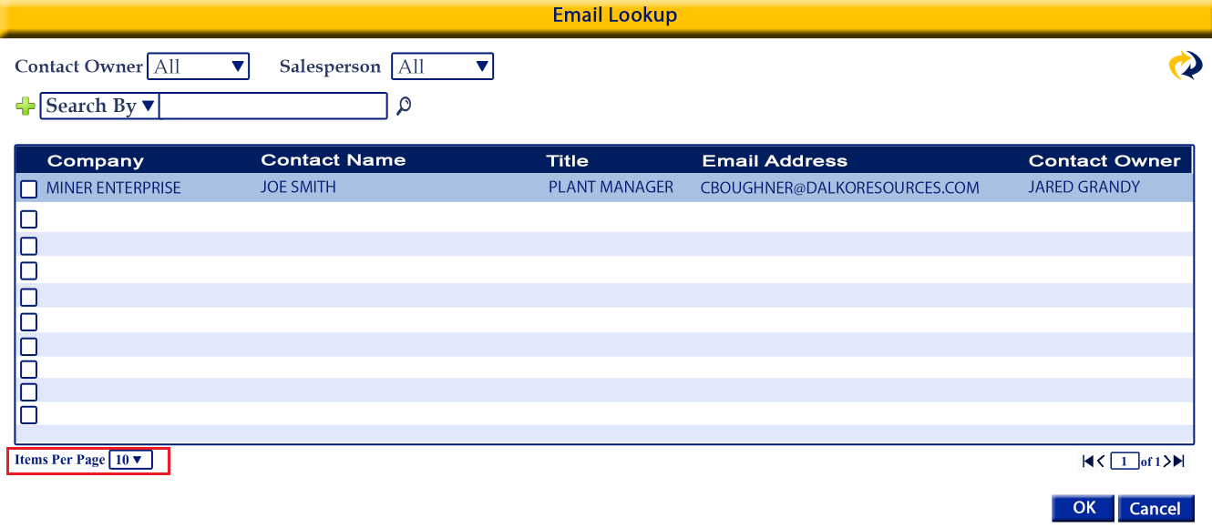
Function:
-Allows the user to choose how many results to show per page
Details
-dropdown menu
-options: 10, 25, 50, 100
-sort numerically
Validation:

Page Number
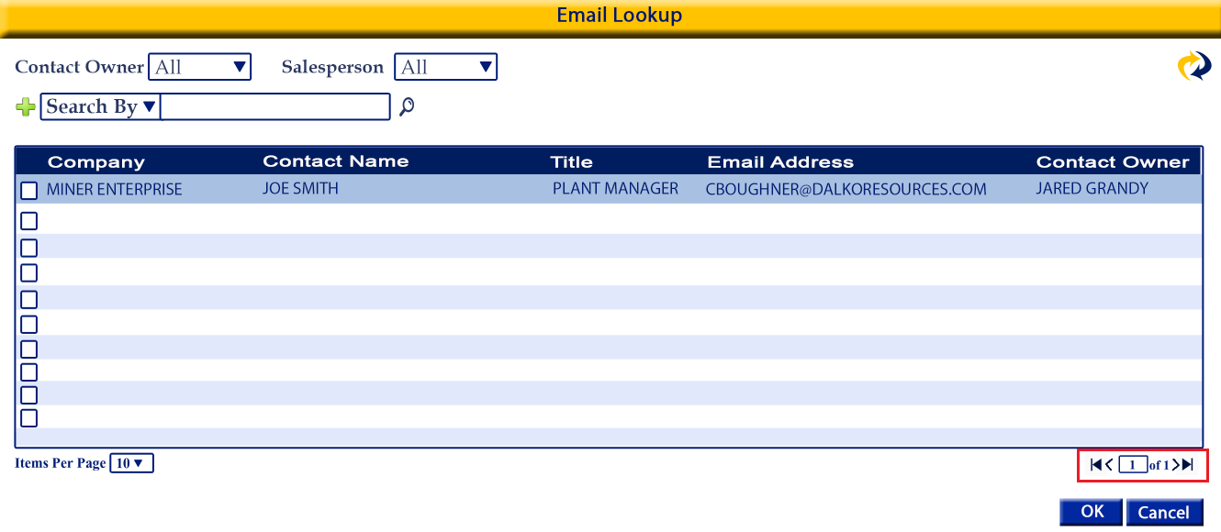
Function:
- displays the page number the user is currently on and how many pages there are in total
Details
-if the user enters a page number and uses the enter key it should jump to that page that the user entered
-single arrow move forward or back one page
-arrow with line jumps to first or last page
Validation:

OK button
Function:
- adds the selected email addresses to the To, Bcc or Cc input field of the New Email window
-where the emails are mapped is based on what button the user clicked to open the email search window
Details
-adds the selected email address to the To, Bcc or Cc input field of the New Email window and closes the Email Lookup window

Validation
-at least one email address must be selected
Message: Please select a contact email

Cancel
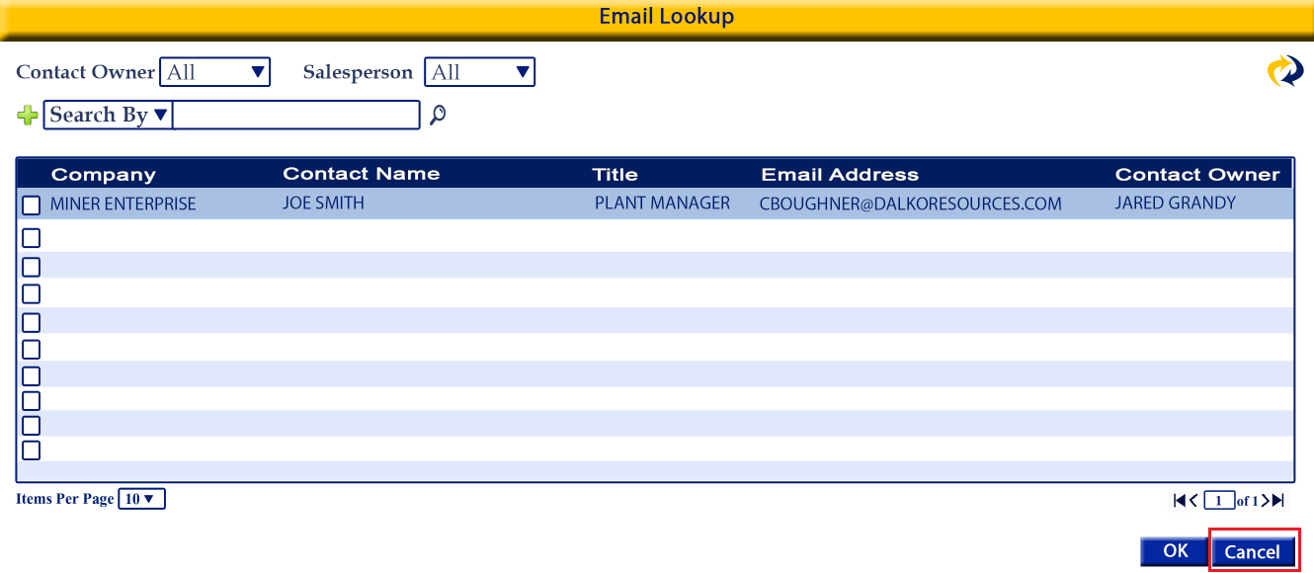
Function:
-closes the Email Lookup window without saving

Details:
-button
- closes the Email Lookup window without adding any email address to the New Email window To, Bcc, or Cc field and returns the user to the New Email window

Validation:
-

New Email: Email Look Up: Results Table
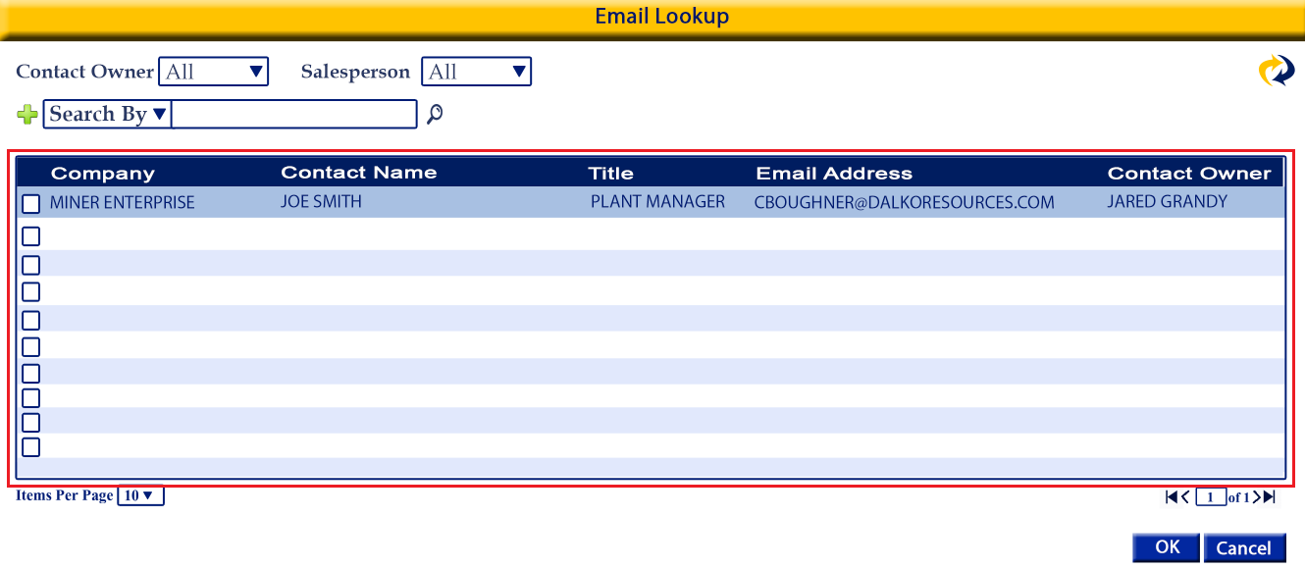
*contact results should be sorted by Company Name then Contact Name by default
*the result table columns should be sortable

Selection checkbox
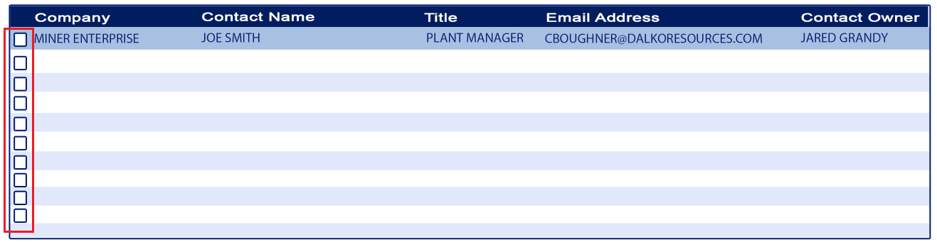
Function:
-allows the user to select one or more email addresses to be added to the To, Bcc or Cc input field of the New Email window
-these are the email address that the user wants to send the email to or copy them in on
Details:
-checkbox
-one for each contact
-located to the left of the Company Name
-user can select one or multiple

Validation:
-at least one must be selected if the Okay button is selected by the user
-if the user clicks Cancel instead of Okay no selection is required

Company Name
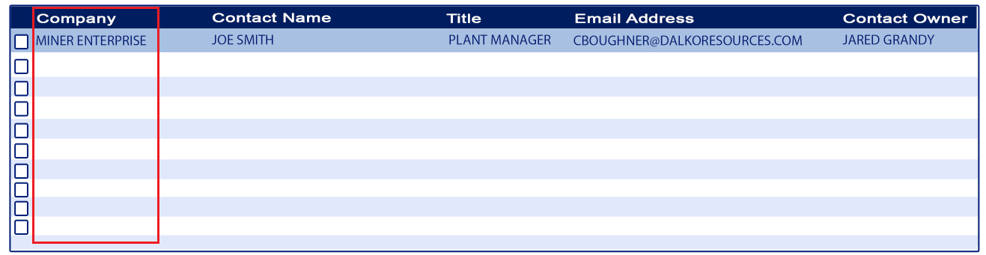
Function:
-displays the nae of the Company the contact is saved to
-informational

Details:
Comes from the Add Contact>Contact Information>Title field

Validation:
-

Contact Name
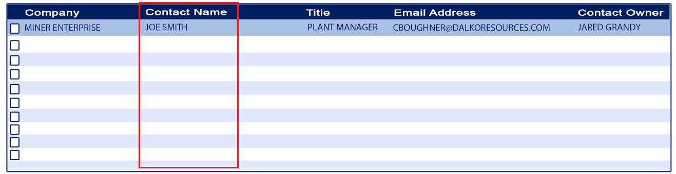
Function:
-displays the full name of the contact
-informational

Details:
-Comes from the Add Contact>Contact Information>First & Last Name fields

Validation:
-

Title
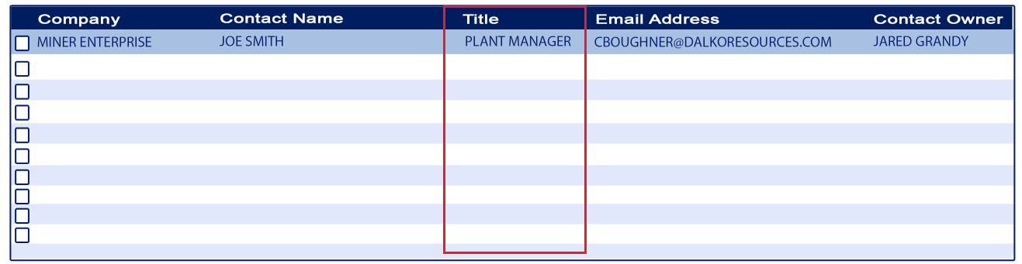
Function:
-displays the title of the contact
-information

Details:
- Comes from the Add Contact>Contact Information>Title field

Validation:
-

Email Address
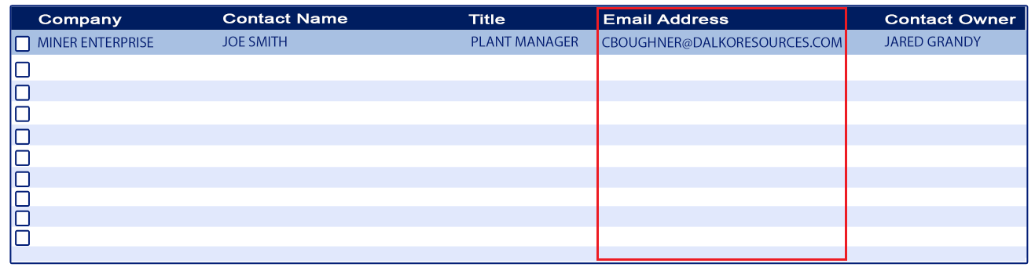
Function:
-displays the email address of the contact
-informational

Details:
-comes from the Add Contact>Contact Information>Primary Email field

Validation:
-

Contact Owner
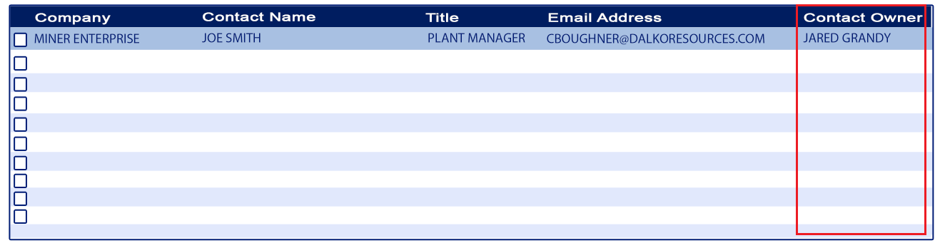
Function:
-displays the owner of the contact
-informational

Details:
-comes from the Add Contact>Contact Information>Contact Owner field

Validation:
-

Prospects Results table
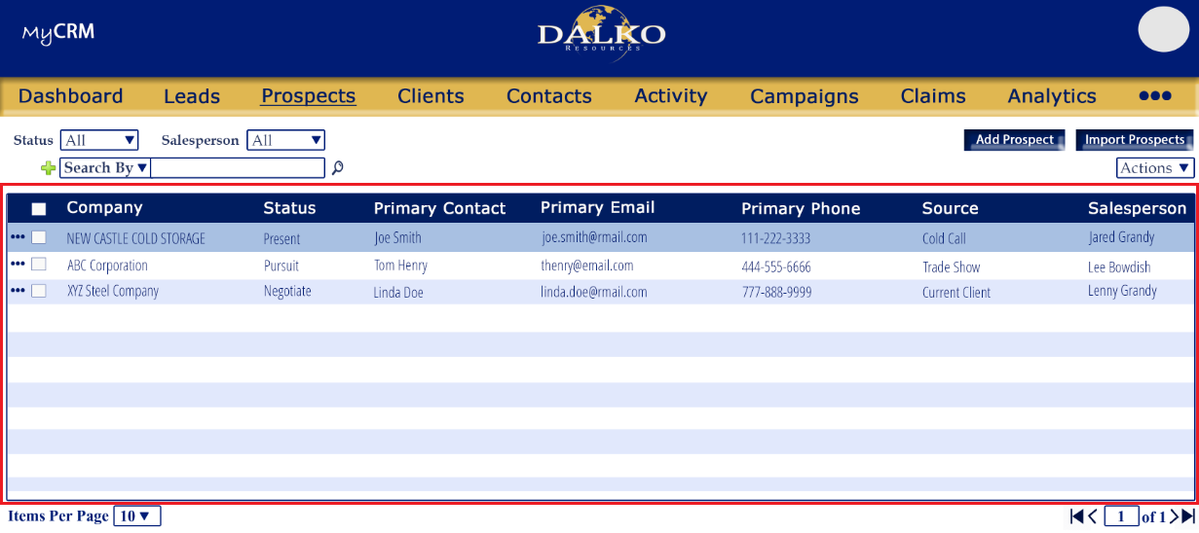

Expanded view
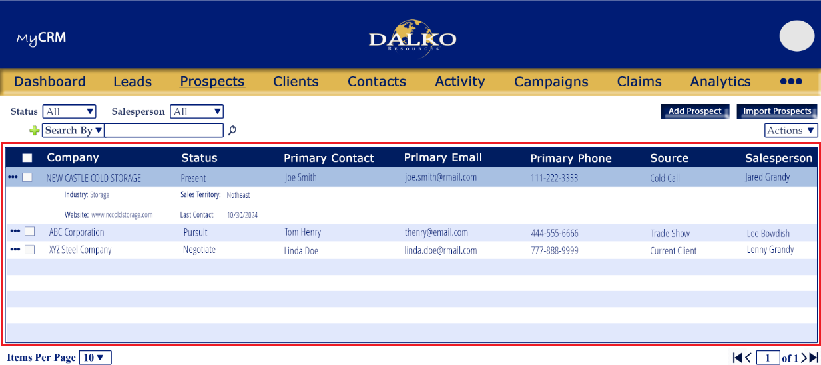
Appearance
-use the images provided for column order and expanded view layout
-all columns and data should be left aligned
-the tabled color scheme should appear as shown in images (color codes details in the general formatting section oat the beginning of this document)
Function:
-displays the existing Prospects
-allows the user to View/Edit, Delete and other functions through the more menu option
Details
-refer to image for appearance and layout
-by default the Prospects will be listed by Company then by Prospect Contact
-all columns should be sortable
-each Prospect should have a More Menu (detailed in this document)
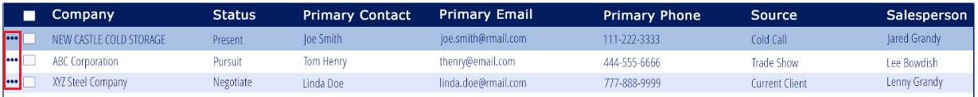
-each Prospect should have a selection box between the More Menu and the Company Name
-unselected by default
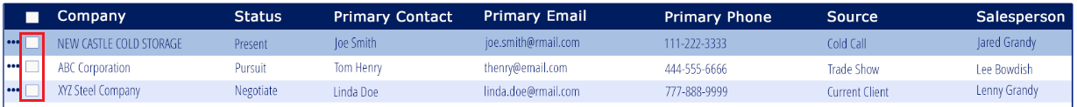
-there should be a Select All checkbox in the table header
-when clicked it will select all Prospect results based on filters and searches applied
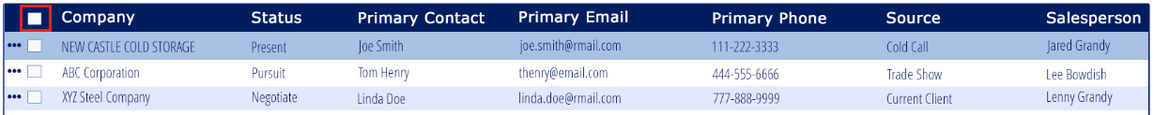

-columns:
- Company
  - Comes from Add Prospect>Company Information>Company name field
- Status
  - Comes from Add Prospect>Company Information>Status field
- Primary Contact
  - Comes from Add Prospect>Company Information>Contact>Primary Contact Name
- Primary Email
  - Comes from Add Prospect>Company Information>Contact>Primary Contact Email
- Primary Phone
  - Comes from Add Prospect>Company Information>Contact>Primary Contact Phone
- Source
  - Comes from Add Prospect>Company Information>Source field
- Salesperson
  - Comes from Add Prospect>Company Information>Salesperson field
-when the Prospect summary line is clicked the Prospect will expand to show more details
**refer to image for layout/appearance
Collapsed
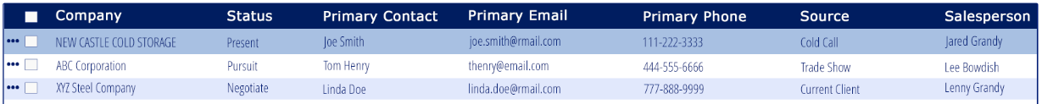

Expanded
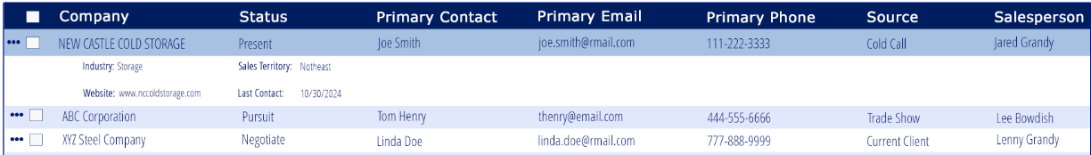
-expanded view will have the following fields
- Industry
  - Comes from Add Prospect>Company Information>Industry field
- Website
  - Comes from Add Prospect>Company Information>Website field
- Sales Territory
  - Comes from Add Prospect>Company Information>Sales Territory field
- Last Contact
  - Comes from Add Prospect>Company Information>Last Contact field

Validation:
-

Results Table More Menu


Function:
-provide the user with additional functions related to the Prospect
Details
-button, menu
-refer to image for placement and appearance
-there should be a Mor Menu for ever Prospect
-Hover text: “More Options”
-More Menu options should be sorted alphabetically except View/Edit
-the View/Edit options should be stuck to the top of the More Menu
-More Menu Options (each will be detailed separately)
- Edit/View
- Add Attachment
- Add Campaign
- Add Contact
- Convert to Client
- Delete
- Schedule Activity
- Send Email

Validation:

Results Table More Menu: Edit/View

Function:
-Allows the user to view and/or edit an existing Prospect
Details
-opens the Add Prospect screen for the selected Prospect

Validation:
-

Results Table More Menu: Add Attachment
Function:
-Allows the user to add an attachment to an existing Prospect
Details
-opens the Attachments: Upload File window
-same function, rules, etc. as clicking the Attachments: Upload File button within the Add Prospect screen
-after the attachment is saved:
- the Attachments: Upload File window will close
- the attachment will be saved under Attachments section of the Add Prospect screen for the selected the company/Prospect it was added under,
- the user will be returned to the Prospects screen

Validation:
- same rules/validations as clicking the Attachments: Upload File button within the Add Prospect screen

Results Table More Menu: Add Campaign

Function:
-Allows the user to add a campaign to an existing Prospect
Details
-opens the Add Campaign window
-same function, rules, etc. as clicking the Add Campaign button within the Add Prospect screen
-after the Campaign is saved the Add Campaign window will close, the Campaign will be saved under the company it was added under and the user will be returned to the Prospects screen

Validation:
- same rules/validations as clicking the Add Campaign button within the Add Prospect screen

Results Table More Menu: Add Contact

Function:
-Allows the user to add a contact to an existing Prospect
Details
-opens the Add Contact screen
-same function, rules, etc. as clicking the Add Contact button within the Add Prospect screen
-after the contact is saved:
  - the Add Contact screen will close
  - the Contact will be saved under Contacts screen
  - the contact will be shown under the Contacts section in the Add Prospects screen for the Prospect it was added under
  - the user will be returned to the Prospects screen

Validation:
- same rules/validations as clicking the Add Contact button within the Add Prospect screen

Results Table More Menu: Convert to Client
Function:
-Allows the user to convert a Prospect to a Client
Details
-same function, rules, etc. as clicking the Convert to Client option within the Add Prospect screen
-after the user completes the fields in the Convert to Client window and clicks proceed:
- The Convert to Client window will close
- The Prospect will be converted to a Client and no longer visible in the Prospect screen
- The company converted to client will only be visible in the Clients screen
- The Status will be update to Client
- the user will be returned to the Prospects screen

Validation:
- same rules/validations as clicking the Convert to Client option within the Add Prospect screen

Results Table More Menu: Delete

Function:
-Allows the user to view delete an existing Prospect
Details
-permanently deletes the Prospect
-Hover text: “Permanently delete Prospect”

Validation:
-if the Prospect has any Subsidiary Companies associated with it the user should not be able to delete the Prospect
Message: “This Prospect is currently has Subsidiary Companies linked to it and cannot be deleted. The Parent Company of the subsidiaries must first be updated.”
Ok button: will close the alert, and return the user to the Prospects screen without deleting the selected Prospect

-there should be a validation on whether the user wishes to proceed
*this validation should occur only if Prospect/Subsidiary company alert is not triggered

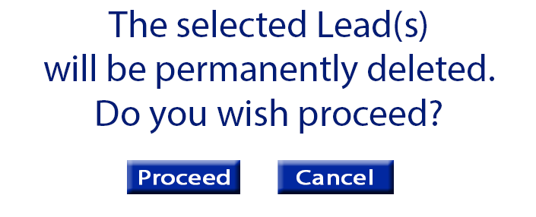

Message: “The selected Prospect(s) will be permanently deleted. Do you wish to continue?”
Proceed: will close the alert and delete the Prospects
Cancel: will close the alert, and return the user to the Prospects screen without deleting the selected Prospect

Results Table More Menu: Schedule Activity
Function:
-Allows the user to add an Activity to an existing Prospect
Details
-opens the Add Activity window
-same function, rules, etc. as clicking the Activities: Add Activity button within the Add Prospect screen
-after the Activity is saved:
- the Add Activity window will close
- the Activity will be saved in the Activities screen
- the Activity will be shown under the Activities section of the Add Prospect screen for company/Prospect it was added under
- the user will be returned to the Prospects screen

Validation:
- same rules/validations as clicking the Activities: Add Activity button within the Add Prospect screen

Results Table More Menu: Send Email
Function:
-Allows the user to send an email to the contact(s) of an existing Prospect
Details
-opens the New Email window
-same function, rules, etc. as detailed in the New Email window detailed previously in this document
-by default the email addresses for all contacts saved to the selected Prospect will be added to the To input field
-the user can remove and/or add
-after the Emails is sent:
- the New Email window will close
- the email will be saved under the Emails section of the Add Prospect screen for company/Prospect it was added under
- the user will be returned to the Prospects screen
Validation:
- same rules/validations as clicking the Emails: Compose Email button within the Add Prospect screen

Results
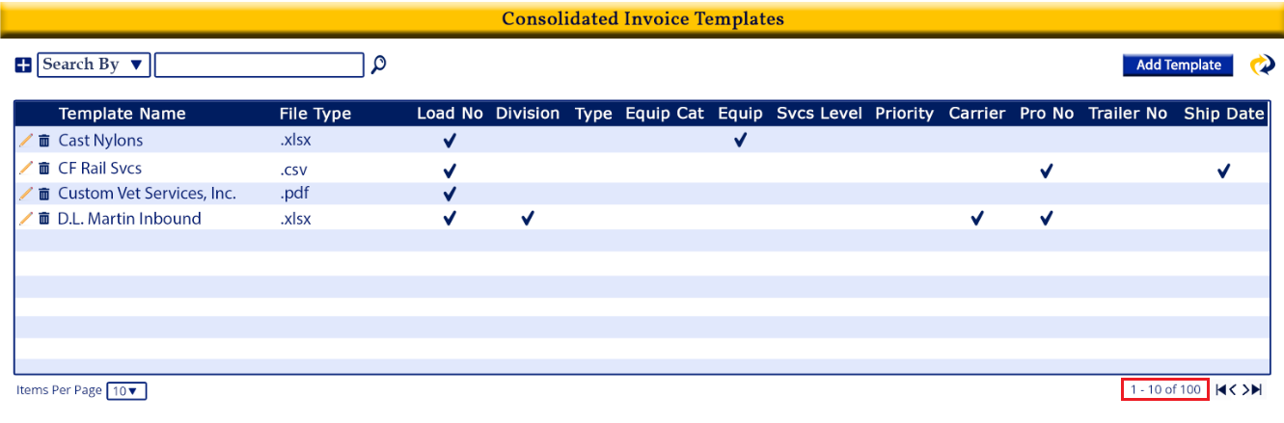
Function:
-Displays the total number of Prospects (all pages, not just the page the user is currently on) based on filters/search applied
Details
-generated by the system
-the total should include all Prospects on all pages
-results are based on what filters and/or search options that were applied
- refer to image below for placement

Validation:
-

Page Navigation
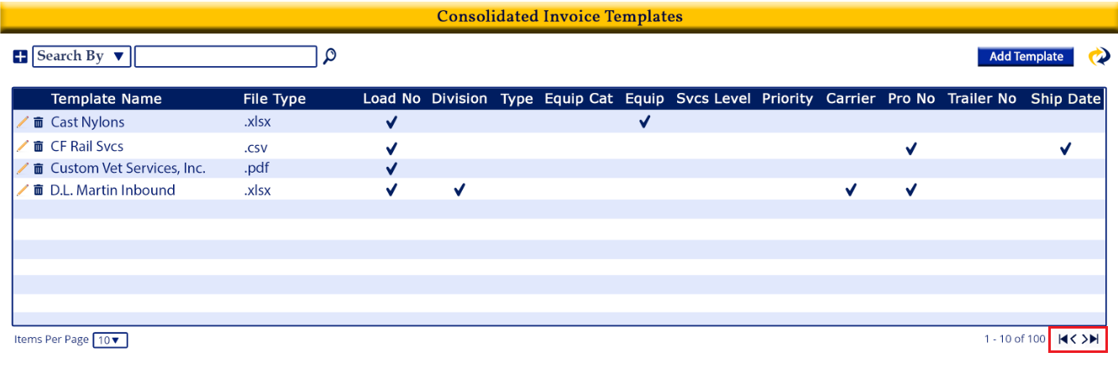
Function:
- allows the user to quickly move through pages
Details
-single arrow move forward or back one page
-arrow with line jumps to first or last page
Validation:

Items per Page
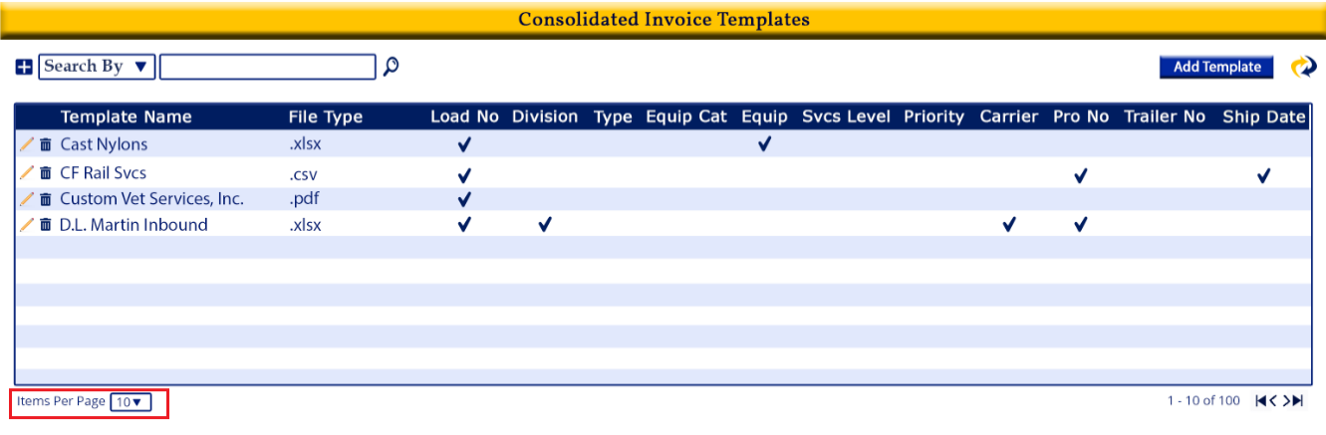
Function:
- displays the number of items shown per page, and allows the user to change it
Details
-dropdown menu where the user can select the number of items per page they want shown
-by default it is 10

Validation:

